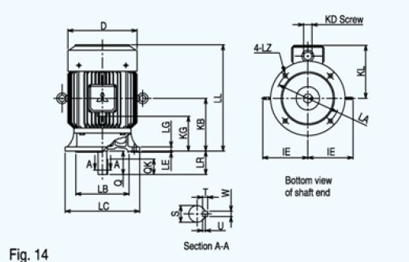
Dimensions are in mm
D | LA | LB | LC | LE | LG | LL | LZ | KG | KL
175 | 165 | 130 | 200 | 3.5 | 10 | 280 | 11 | 40 | 130

SHAFT
LR | Q | QK | S | T | U | W
50 | 50 | 40 | 24 | 7 | 4 | 8

