Spare Parts Dry Shut Gun 8KPSl
Dry Shut Gun Spare Parts Assembly
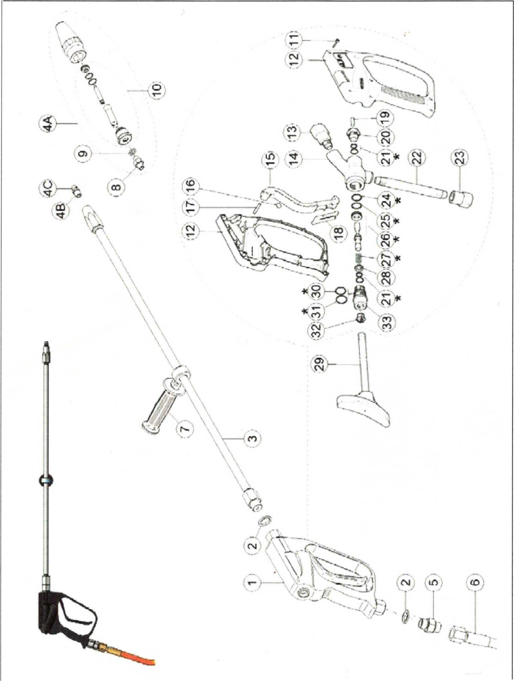
DEN

JET

